This estimation cost was created only for Production and it have redundance on all tier with multi availability zone including RDS and EC2

This estimation may change depending on the add or remove resource and region.

Production Environment.

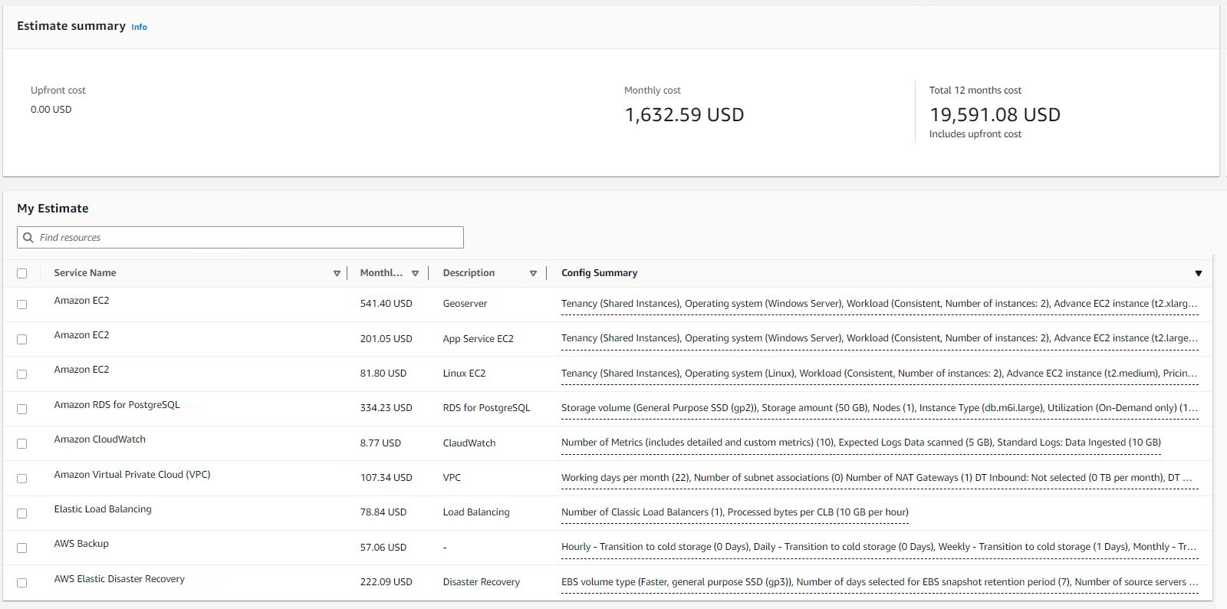

Staging Environment

